|  |  |  |  |
| --- | --- | --- | --- |
| 1 | | 327,163 | |
| **NUMERO DE FRONTERAS** | | **ENERGIA AGREGADA** | |
|  | | | |
| 1,156,126,323 | 143 | | 43,710,382 |
| INGRESO 2019 | DÍAS CERTIFICADOS 2019 | | ENERGIA RESPALDADA 2019 |
|  | | | |
| 1,177,147,920 | 176 | | 45,857,324 |
| INGRESO 2020 | DÍAS CERTIFICADOS 2020 | | ENERGIA RESPALDADA 2020 |
|  | | | |
| 1,071,237,672 | 156 | | 47,712,266 |
| INGRESO 2021 | DÍAS CERTIFICADOS 2021 | | ENERGIA RESPALDADA 2021 |

**HISTORICO REINTEGRO DDV**

|  |  |  |  |
| --- | --- | --- | --- |
|  | **2019** | **2020** | **2021** |
| **ENE** | - | 216.52 | 142.99 |
| **FEB** | 111.26 | 271.64 | 165.58 |
| **MAR** | 6.71 | 55.79 | 39.21 |
| **ABR** | 24.5 | 6.62 | - |
| **MAY** | 164.8 | 35.8 | 144.85 |
| **JUN** | 118.88 | 61.1 | 147.36 |
| **JUL** | 183.35 | 164.2 | 184.4 |
| **AGO** | - | 90.96 | 42.79 |
| **SEP** | - | 37.8 | 86.13 |
| **OCT** | 143.67 | 54.42 | 117.93 |
| **NOV** | 260.47 | 9.23 | - |
| **DIC** | 142.48 | 173.07 | - |

**Los valores de la tabla están en millones de COP**

**REINTEGRO MECANISMO DDV OCTUBRE 2021**

|  |  |  |  |  |  |
| --- | --- | --- | --- | --- | --- |
| FECHA | TIPO DIA | CANTIDADES RESPALDO | PRECIO PONDERADO USD | TRM | PNETO |
| 2021-10-06 | Miércoles | 309,979 | 5.98 | 3,784.44 | 6,285,547 |
| 2021-10-07 | Jueves | 309,987 | 5.98 | 3,784.44 | 6,285,709 |
| 2021-10-08 | Viernes | 309,938 | 5.98 | 3,784.44 | 6,284,716 |
| 2021-10-09 | Sábado | 309,987 | 5.98 | 3,784.44 | 6,285,709 |
| 2021-10-10 | Domingo - Festivo | 330,314 | 5.98 | 3,784.44 | 6,697,887 |
| 2021-10-11 | Lunes | 330,314 | 5.98 | 3,784.44 | 6,697,887 |
| 2021-10-12 | Martes | 330,314 | 5.98 | 3,784.44 | 6,697,887 |
| 2021-10-13 | Miércoles | 330,325 | 5.98 | 3,784.44 | 6,698,110 |
| 2021-10-19 | Martes | 330,314 | 5.98 | 3,784.44 | 6,697,887 |
| 2021-10-20 | Miércoles | 330,314 | 5.98 | 3,784.44 | 6,697,887 |
| 2021-10-21 | Jueves | 330,314 | 5.98 | 3,784.44 | 6,697,887 |
| 2021-10-22 | Viernes | 325,346 | 5.98 | 3,784.44 | 6,597,149 |
| 2021-10-23 | Sábado | 325,346 | 5.98 | 3,784.44 | 6,597,149 |
| 2021-10-24 | Domingo - Festivo | 321,290 | 5.98 | 3,784.44 | 6,514,904 |
| 2021-10-25 | Lunes | 309,987 | 5.98 | 3,784.44 | 6,285,709 |
| 2021-10-26 | Martes | 330,314 | 5.98 | 3,784.44 | 6,697,887 |
| 2021-10-27 | Miércoles | 330,325 | 5.98 | 3,784.44 | 6,698,110 |
| 2021-10-28 | Jueves | 321,301 | 5.98 | 3,784.44 | 6,515,127 |

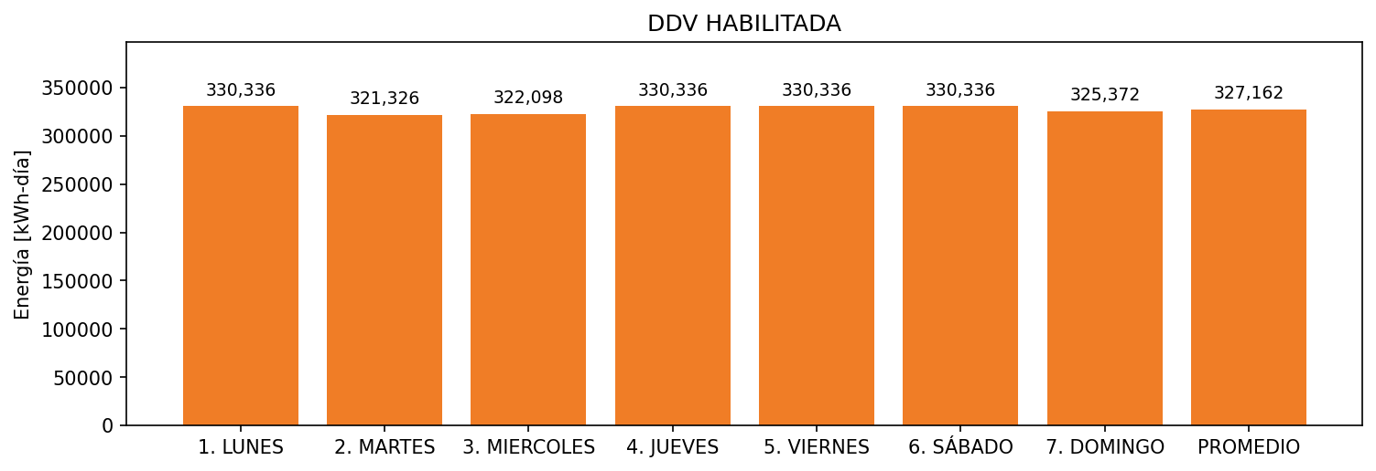

|  |  |  |  |  |  |  |  |  |  |
| --- | --- | --- | --- | --- | --- | --- | --- | --- | --- |
| **FRONTERA** | **COD SIC** | **FRT DDV** | **TIPO DDV** | **PROMEDIO** | **PRÓXIMA ACTUALIZACIÓN** | **MARGEN DE ERROR** | **ÚLTIMA PRUEBA DDV** | **DÍAS PARTICIPACIÓN** | **FECHA REFERENCIA PRÓXIMA PRUEBA DDV** |
| PRODUCTOS FAMILIA S.A. 1 | Frt05879 | Frt31827 | LBC | 327,162 | 2021-12-07 | 4,54 | 2021-09-27 | 18.0 | 2022-02-23 |